Limelight Video Platform Android SDK

Prerequisites
- Target Android OS 4.0 to latest 5.x
- Eclipse
- Android SDK 4.0(building with 4.0 to support from 4.0 onwards)
- A Limelight Orchestrate Video account

Installation
To add LimelightVideoKit manually to your project follow these steps:
- Download the limelightvideosdk.jar for Android.
- Add the limelightvideosdk.jar to “libs” directory of your project.

How to create Simple Application using LimelightVideoSDK
This tutorial helps you create basic application using limelightvideosdk.jar to play a sample media.
There are two ways to try this Sample Application.
- Manually setup the project by following the steps below.
- Download the sample project as a starting point from Github
  - Get the entire project from Github.
  - Import to eclipse.
  - Build and run the project.

Create the project in Eclipse.
If you do not have it already install Eclipse 4.4 or later.
- Create a new project in Eclipse. Open Eclipse and from Menu select File -> New -> Android Application Project. The following screen gets displayed.
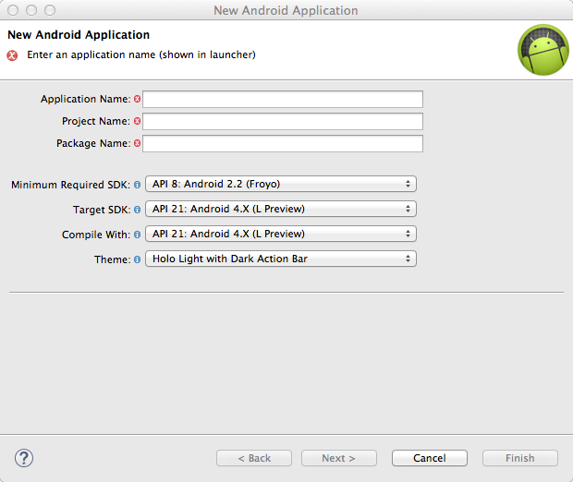

- Set the project details as follows.
Application Name: Desired applciartion name (llSKTest2 is given in the screen)
Project Name: 'YourProjectName' (given llSKTest2 in the screen)
PackageName: 'YourPackageName' (given com.example.llSKTest2 in the screen)
Minimum Required SDK : API 14(supporting from API 14)
Target SDK: API 14 (Could choose latest 5.x)
Compile With: Could be latest (given API 21 in the screen)
Theme: Select None.
Choose “Next” to proceed to next screen.
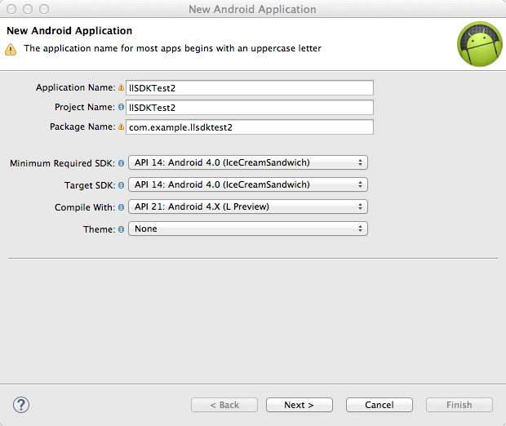

- Configure the project as follows
Select “Create custom launcher icon”.
Select “Create activity”.
Don’t select “Mark this project as a library”.
Select “Create Project in workspace”.
Provide the location or use the “Browse…” button.
Choose “Next” to proceed to next screen.
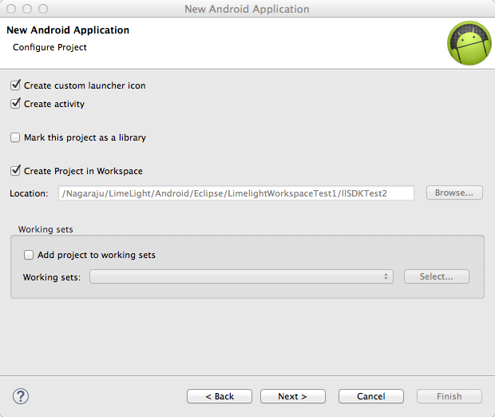

- Configure Launcher Icon.
Select “Image” from Foreground:
Provide the Image file (png image) path or use the “Browse…” button.
Choose “Next” to proceed to next screen.

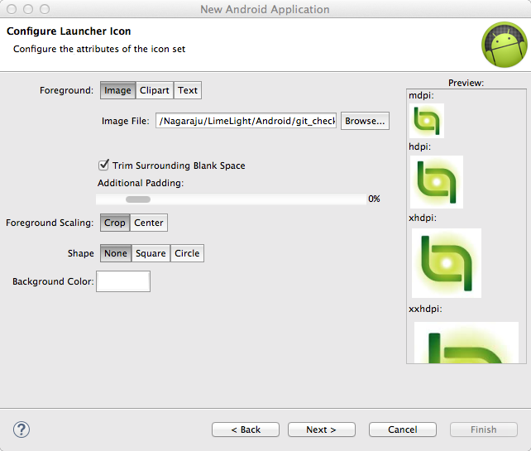

- Choose Activity type.
Select “Tabbed Activity” from the different activity types displayed.
Choose “Next” to proceed to next screen.

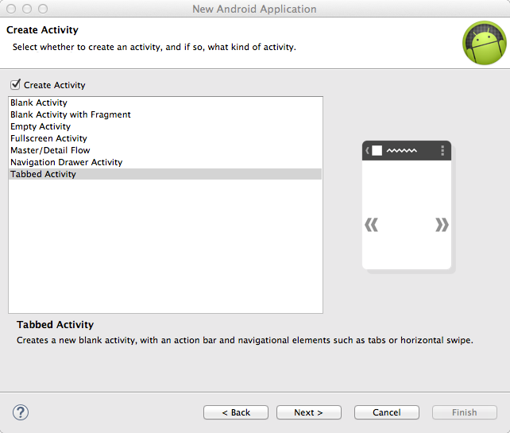

- Configure Activity Name.
Activity Name: “MainActivity”.
Layout Name: “activity_main”.
Fragment Layout Name: “fragment_main”
Navigation Style: Action Bar Tabs (with ViewPager).
Choose “Next” to proceed to create the project.

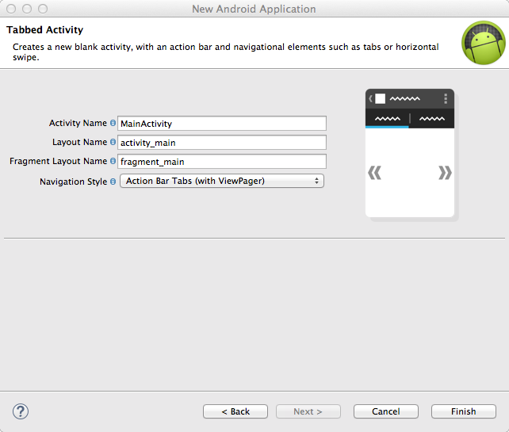

Adding SDK and setting up your project.
- Download the limelightvideosdk.jar for Android.
- Add the limelightvideosdk.jar to “libs” directory of your project.
- Open “AndroidManifest.xml” under project folders in Eclipse, edit “AndroidManifest.xml” using xml tab to have the following contents.
Under
<application
<activity
Add the following:
android:configChanges="keyboard|keyboardHidden|screenSize|orientation|screenLayout|touchscreen|uiMode"
- After the activity block add the following(for full screen player):
<activity android:name="com.limelight.videosdk.FullScreenPlayer" android:configChanges="keyboard|keyboardHidden|screenSize|orientation|screenLayout|touchscreen|uiMode">
</activity>
- Switch to “AndroidManifest.xml” Permission tab and add the following permissions, Add as user permissions:
android.permission.ACCESS_NETWORK_STATE
android.permission.INTERNET
android.permission.WRITE_EXTERNAL_STORAGE

Code the simple video player application
You are just few steps away from playing sample media in your application.
- Open the activity_main.xml under res->layout, the contents should be like the following.
<android.support.v4.view.ViewPager xmlns:android="http://schemas.android.com/apk/res/android"
xmlns:tools="http://schemas.android.com/tools"
android:id="@+id/pager"
android:layout_width="match_parent"
android:layout_height="match_parent"
tools:context="com.example.llsdktest2.MainActivity" />
- Remove fragment_main.xml we will create our own fragment xml files.
- Under res-> layout create the following resource xml files as from Menu File->New->Android XML File. Resource xmlswith names fragment_media, fragment_player, list_media and toast.
- Contents of fragment_media.xml should bas as the following:
<?xml version="1.0" encoding="utf-8"?>
<android.support.v4.widget.SwipeRefreshLayout xmlns:android="http://schemas.android.com/apk/res/android"
android:id="@+id/swipe_container"
android:layout_width="match_parent"
android:layout_height="match_parent" >
<LinearLayout
xmlns:android="http://schemas.android.com/apk/res/android"
android:layout_width="match_parent"
android:layout_height="match_parent"
android:orientation="vertical"
android:paddingLeft="8dp"
android:paddingRight="8dp" >
<ListView
android:id="@id/android:list"
android:layout_width="match_parent"
android:layout_height="0dp"
android:layout_weight="1"
android:drawSelectorOnTop="false" />

<TextView
android:id="@id/android:empty"
android:layout_width="match_parent"
android:layout_height="0dp"
android:layout_weight="1"
android:gravity="center"
android:text="No data"
android:visibility="gone" />
<ProgressBar
android:id="@+id/progress"
android:layout_width="wrap_content"
android:layout_height="match_parent"
android:layout_gravity="center" />
<ProgressBar
android:id="@+id/progress_load"
android:layout_width="wrap_content"
android:layout_height="wrap_content"
android:layout_gravity="center" />
<LinearLayout
android:layout_width="match_parent"
android:layout_height="50dp"
android:orientation="horizontal"
android:paddingLeft="8dp"
android:paddingRight="8dp" >
</LinearLayout>
</LinearLayout>
</android.support.v4.widget.SwipeRefreshLayout>

- Contents of fragment_player.xml should bas as the following:
<LinearLayout xmlns:android="http://schemas.android.com/apk/res/android"
xmlns:tools="http://schemas.android.com/tools"
android:layout_width="match_parent"
android:layout_height="match_parent"
android:orientation="vertical"
tools:context=".MainActivity" >
<RelativeLayout
android:id="@+id/videoLayout"
android:layout_width="match_parent"
android:layout_height="0dp"
android:layout_weight="1"
android:divider="@android:drawable/divider_horizontal_dark"
android:gravity="center" >
</RelativeLayout>
</LinearLayout>

- Contents of list_media.xml should bas as the following:
<?xml version="1.0" encoding="utf-8"?>
<RelativeLayout xmlns:android="http://schemas.android.com/apk/res/android"
android:layout_width="match_parent"
android:layout_height="match_parent"
android:padding="10dp"
android:background="@android:color/background_light">
<FrameLayout
android:id="@+id/imageContainer"
android:layout_width="80dp"
android:layout_height="80dp"
android:layout_alignParentLeft="true"
android:layout_centerVertical="true"
android:paddingRight="10dp" >
<ProgressBar
android:id="@+id/progressThumbnail"
style="@android:style/Widget.ProgressBar.Small"
android:layout_width="wrap_content"
android:layout_height="wrap_content"
android:layout_gravity="center" >
</ProgressBar>
<ImageView
android:id="@+id/image"
android:layout_width="match_parent"
android:layout_height="match_parent" />
</FrameLayout>
<TextView
android:id="@+id/text"
android:layout_width="wrap_content"
android:layout_height="wrap_content"
android:layout_centerVertical="true"
android:layout_toRightOf="@id/imageContainer"
android:gravity="center"
android:lines="2"
android:textSize="16sp"
android:layout_marginRight="120dp"
android:textColor="@android:color/black"
android:text="No data" />
</RelativeLayout>

- Contents of toast.xml should bas as the following:
<?xml version="1.0" encoding="utf-8"?>
<TextView xmlns:android="http://schemas.android.com/apk/res/android"
android:id="@+id/text"
android:layout_width="match_parent"
android:layout_height="wrap_content"
android:padding="10dp" style="@android:style/TextAppearance.DeviceDefault.Widget.TextView.PopupMenu"
android:textSize="30sp" >
</TextView>

- Edit MainActivity.java located user the “src” folder.
- Modify the class implementation as the following:
public class MainActivity extends FragmentActivity implements IPlayerCallback, OnPageChangeListener,ActionBar.TabListener
- Implementing IPlayerCallback from SDK to communicate with the SDK.
- In onCreate add the following to configure the SDK(these are optional if not provided the SDK will use the default production values.)
Setting.configureLimelightSettings(<Limelight API End point URL>, <Limelight license proxy URL>, <Limelight portal key>);
LoggerUtil.setLogLevelByString("Debug",this);
Setting.SetAnalyticsEndPoint("https://staging-mcs.lvp.llnw.net/r/MetricsCollectionService/recordMetricsEvent");
- Add a member to hold the channel ID as the following
private String mChannelID = <your channel ID>;
- Using mouse hover on “MainActivity” class to add un-implemented methods.
- The contents of “MainActivity” should look like the following:
package com.example.llsdktest2;
import com.limelight.videosdk.Constants;
import com.limelight.videosdk.ContentService;
import com.limelight.videosdk.IPlayerCallback;
import com.limelight.videosdk.IPlayerControl;
import com.limelight.videosdk.LoggerUtil;
import com.limelight.videosdk.Constants.PlayerState;
import com.limelight.videosdk.utility.Setting;
import com.example.llsdktest2.MediaOfChannel.MediaOfChannelCallback;
import android.app.ActionBar;
import android.app.FragmentTransaction;
import android.support.v4.app.FragmentActivity;
import android.support.v4.view.ViewPager;
import android.support.v4.view.ViewPager.OnPageChangeListener;
import android.support.v4.app.Fragment;
import android.support.v4.app.FragmentManager;
import android.support.v4.app.FragmentPagerAdapter;
import android.util.SparseArray;
import android.os.Bundle;

public class MainActivity extends FragmentActivity implements IPlayerCallback, OnPageChangeListener,ActionBar.TabListener {
private String mChannelID = "your_channle_id";
private PlayersFragment mPlayersFragment = null;
private MediaOfChannel mMediaOfChannelFragment = null;
private IPlayerControl mControl;
private SparseArray<Fragment> mRefer = new SparseArray<Fragment>();

/**
* The {@link android.support.v4.view.PagerAdapter} that will provide
* fragments for each of the sections. We use a {@link FragmentPagerAdapter}
* derivative, which will keep every loaded fragment in memory. If this
* becomes too memory intensive, it may be best to switch to a
* {@link android.support.v13.app.FragmentStatePagerAdapter}.
*/
SectionsPagerAdapter mSectionsPagerAdapter;

/**
* The {@link ViewPager} that will host the section contents.
*/
ViewPager mViewPager;

@Override
protected void onCreate(Bundle savedInstanceState) {
super.onCreate(savedInstanceState);

//configuring SDK
Setting.configureLimelightSettings("https://staging-api.lvp.llnw.net/rest", "https://staging-wlp.lvp.llnw.net/license", "limelight");
LoggerUtil.setLogLevelByString("Debug",this);
Setting.SetAnalyticsEndPoint("https://staging-mcs.lvp.llnw.net/r/MetricsCollectionService/recordMetricsEvent");

setContentView(R.layout.activity_main);

// Set up the action bar.
final ActionBar actionBar = getActionBar();
actionBar.setNavigationMode(ActionBar.NAVIGATION_MODE_TABS);

// Create the adapter that will return a fragment for each of the three
// primary sections of the activity.
mSectionsPagerAdapter = new SectionsPagerAdapter(getSupportFragmentManager());

// Set up the ViewPager with the sections adapter.
mViewPager = (ViewPager) findViewById(R.id.pager);
mViewPager.setOnPageChangeListener(this);
mViewPager.setAdapter(mSectionsPagerAdapter);
mViewPager.setOffscreenPageLimit(2);
actionBar.addTab(actionBar.newTab().setText(mSectionsPagerAdapter.getPageTitle(0)).setTabListener(this)); actionBar.addTab(actionBar.newTab().setText(mSectionsPagerAdapter.getPageTitle(1)).setTabListener(this));
}

MediaOfChannelCallback mediaOfChannelCallback = new MediaOfChannelCallback() {
@Override
public void playMediaId(String id, ContentService svc) {
if(mPlayersFragment != null){
mPlayersFragment.play(svc,id);
}
mViewPager.setCurrentItem(1);
}
};

@Override
public void onTabSelected(ActionBar.Tab tab,
FragmentTransaction fragmentTransaction) {
// When the given tab is selected, switch to the corresponding page in
// the ViewPager.
mViewPager.setCurrentItem(tab.getPosition());
}

@Override
public void onTabUnselected(ActionBar.Tab tab,
FragmentTransaction fragmentTransaction) {
}

@Override
public void onTabReselected(ActionBar.Tab tab,
FragmentTransaction fragmentTransaction) {
}

/**
* A {@link FragmentPagerAdapter} that returns a fragment corresponding to
* one of the sections/tabs/pages.
*/
public class SectionsPagerAdapter extends FragmentPagerAdapter {

private int mPageCount = 2;
public SectionsPagerAdapter(FragmentManager fm) {
super(fm);
}

public void setCount(int val) {
mPageCount = val;
}

@Override
public Fragment getItem(int position) {
Fragment retFragment = null;

if(position ==0){
mMediaOfChannelFragment = new MediaOfChannel(mediaOfChannelCallback,mChannelID);
retFragment = mMediaOfChannelFragment;
}else if(position ==1){
mPlayersFragment = new PlayersFragment();
mRefer.put(0, mPlayersFragment);
retFragment = mPlayersFragment;
}
return retFragment;
}

@Override
public int getCount() {
return 2;
}

@Override
public CharSequence getPageTitle(int position) {
String title = "";
switch (position) {
case 0:
title = getResources().getString(R.string.title_media_of_channel);
break;
case 1:
title = getResources().getString(R.string.title_player);
break;
}
return title;

}
}

@Override
public void onPageScrollStateChanged(int arg0) {}
@Override
public void onPageScrolled(int arg0, float arg1, int arg2) { }

@Override
public void onPageSelected(int page) {
if (mPlayersFragment == null) {
mPlayersFragment = (PlayersFragment) mRefer.get(0);
}
if (mPlayersFragment != null){
mPlayersFragment.hideController();
//page is for player
if(page == 1){
if(mPlayersFragment.getPlayerState() != PlayerState.stopped.ordinal())//stopped
mPlayersFragment.show();
}else{
if(mPlayersFragment.getPlayerState() != PlayerState.stopped.ordinal())//stopped
mControl.pause();
}
}
getActionBar().setSelectedNavigationItem(page);
}

@Override
public void playerAttached(IPlayerControl control) {
mControl = control;
//sometimes the mPlayerFragment can be null as it gets destroyed by the system, so using the cashed object
if (mPlayersFragment == null){
mPlayersFragment = (PlayersFragment) mRefer.get(0);
}
if (mPlayersFragment != null){
mPlayersFragment.setControl(mControl);
mPlayersFragment.showProgress(false,null);
}
}

@Override
public void playerMessage(int messageType,int value,String message) {
if (mPlayersFragment == null) {
mPlayersFragment = (PlayersFragment) mRefer.get(0);
}
if(mPlayersFragment != null){
if(messageType == Constants.Message.status.ordinal()){
if(value == Constants.PlayerState.completed.ordinal()){

}else{
mPlayersFragment.showProgress(true,message);
}
}
else if(messageType == Constants.Message.error.ordinal()){
mPlayersFragment.hide();
mPlayersFragment.showProgress(false,null);
mPlayersFragment.showMessage(message);
}
else if(messageType == Constants.Message.progress.ordinal()){
mPlayersFragment.hide();
mPlayersFragment.showProgress(false,null);
mPlayersFragment.showProgressDialog(value);
}
else{
mPlayersFragment.hide();
mPlayersFragment.showProgress(false,null);
mPlayersFragment.showMessage(message);
}
}
}

@Override
public void playerPrepared(IPlayerControl control) {

mControl = control;
if (mPlayersFragment == null)
mPlayersFragment = (PlayersFragment) mRefer.get(0);
if (mPlayersFragment != null) {
mPlayersFragment.setControl(mControl);
mPlayersFragment.showProgress(false,null);
mPlayersFragment.show();
mPlayersFragment.showKeyboard(false);
}
}
}

- Create new classes user “src” folder from File->New-> “Class”.
- The names of classes are MediaOfChannel, ModelHolder, ListAdapter and PlayersFragment
- The contents of “MediaOfChannel” should look like the following:
package com.example.llsdktest2;
import java.util.ArrayList;
import com.limelight.videosdk.Constants;
import com.limelight.videosdk.ContentService;
import com.limelight.videosdk.model.Media;
import com.limelight.videosdk.model.Media.MediaThumbnail;
import android.content.Context;
import android.net.Uri;
import android.os.Bundle;
import android.support.v4.app.Fragment;
import android.support.v4.app.LoaderManager;
import android.support.v4.content.AsyncTaskLoader;
import android.support.v4.content.Loader;
import android.view.LayoutInflater;
import android.view.View;
import android.view.ViewGroup;
import android.widget.AbsListView;
import android.widget.AdapterView;
import android.widget.ListView;
import android.widget.ProgressBar;
import android.widget.TextView;
import android.widget.AbsListView.OnScrollListener;
import android.widget.AdapterView.OnItemClickListener;

class MediaOfChannel extends Fragment implements LoaderManager.LoaderCallbacks<ModelHolder>,OnItemClickListener,OnScrollListener{
private static String organizationID = "YOUR_ORGANIZATION_ID";
private static String accessKey = "YOUR_ACCESS_KEY";
private static String secretKey = "YOUR_SECRET_KEY";
private ListView mListView;
private TextView mTextView;
private ProgressBar mProgress;
private ProgressBar mProgressLoad;
private static String mChannelId = null;
private static String mErrorMsg;
private MediaOfChannelCallback mActivityCallback;
private int mPreviousTotalCount = 0;
private static ContentService mContentService = null;
private static ArrayList<Media> mMedias = null;
private ListAdapter mAdapter;
private static final int TYPE_MEDIA = 3;
public MediaOfChannel(MediaOfChannelCallback callback,String id) {
mActivityCallback = callback;
mChannelId = id;
mAdapter= null;
mListView= null;
}

@Override
public View onCreateView(LayoutInflater inflater,ViewGroup container, Bundle savedInstanceState) {
View view = inflater.inflate(R.layout.fragment_media, container,false);

mListView = (ListView) view.findViewById(android.R.id.list);
mTextView = (TextView) view.findViewById(android.R.id.empty);
mProgress = (ProgressBar) view.findViewById(R.id.progress);
mProgressLoad = (ProgressBar) view.findViewById(R.id.progress_load);
mListView.setOnItemClickListener(this);
mListView.setOnScrollListener(this);
return view;
}
@Override
public void onActivityCreated(Bundle savedInstanceState) {
super.onActivityCreated(savedInstanceState);
setEmptyText("No Channel Selected");
mAdapter = new ListAdapter(getActivity(),TYPE_MEDIA);
mListView.setAdapter(mAdapter);
setListShown(false);
if(mChannelId == null){
setListShown(true);
}
else{
getActivity().getSupportLoaderManager().initLoader(13, null, this);
}
}
public interface MediaOfChannelCallback{
void playMediaId(String mediaId, ContentService contentservice);
}

private void setEmptyText(String string) {
mTextView.setText(string);
}
private void setListShown(boolean b) {
mProgressLoad.setVisibility(View.GONE);
if(b){
//Hide progress
mProgress.setVisibility(View.GONE);
//hide text if list exist
if(mMedias!= null && mMedias.size()>0){
mListView.setVisibility(View.VISIBLE);
mTextView.setVisibility(View.GONE);
}else{
mListView.setVisibility(View.GONE);
mTextView.setVisibility(View.VISIBLE);
}
}else{
//show progress hide text hide list
mListView.setVisibility(View.GONE);
mTextView.setVisibility(View.GONE);
mProgress.setVisibility(View.VISIBLE);
}
}

private void loadMore(){
mProgressLoad.setVisibility(View.VISIBLE);
Bundle b = new Bundle();
b.putBoolean("Refresh", true);
if(mChannelId != null){
getActivity().getSupportLoaderManager().restartLoader(13, b, this);
}
}
@Override
public void onScroll(AbsListView view, int firstVisibleItem, int visibleItemCount, int totalItemCount) {
if (totalItemCount == 0 || mAdapter == null)
return;
if (mPreviousTotalCount == totalItemCount)
return;
boolean loadMore = (firstVisibleItem + visibleItemCount >= totalItemCount);
if (loadMore){
//Fetching next page data
mPreviousTotalCount = totalItemCount;
loadMore();
}
}
@Override
public void onScrollStateChanged(AbsListView arg0, int arg1) {

}
@Override
public void onItemClick(AdapterView<?> arg0, View arg1, int position, long arg3) {
if((mContentService.getOrgId().equalsIgnoreCase(organizationID) == false) ||
(mContentService.getAccessKey().equalsIgnoreCase(accessKey) == false) ||
(mContentService.getSecret().equalsIgnoreCase(secretKey) == false)){
mContentService = new ContentService(getActivity(),organizationID,accessKey,secretKey);
}
if(mMedias!= null && !mMedias.isEmpty()){
mActivityCallback.playMediaId(mMedias.get(position).mMediaID, mContentService);
}
}
@Override
public Loader<ModelHolder> onCreateLoader(int arg0, Bundle arg1) {

MediaOfChannelLoader loader = new MediaOfChannelLoader(MediaOfChannel.this.getActivity(),arg1);
loader.forceLoad();
return loader;
}
@Override
public void onLoadFinished(Loader<ModelHolder> arg0, ModelHolder arg1) {

if(mMedias == null){
setEmptyText(mErrorMsg);
setListShown(true);
}
else if(mMedias.size()==0){
setEmptyText("No Media Found In This Channel");
setListShown(true);
}
mAdapter.setData(arg1.getTitles(),arg1.getUrls(),arg1.getIds());
mAdapter.notifyDataSetChanged();
setListShown(true);
}
@Override
public void onLoaderReset(Loader<ModelHolder> arg0) {
mAdapter.setData(null, null, null);
mListView.setAdapter(null);
}
/**
* This class is to fetch all the media of channel asynchronously.
*
*/
private static class MediaOfChannelLoader extends AsyncTaskLoader<ModelHolder> {

private ModelHolder mHolder;
private boolean refresh = false;
private Context mContext;

public MediaOfChannelLoader(Context context, Bundle arg1) {
super(context);
mContext = context;
if(arg1!= null){
refresh = arg1.getBoolean("Refresh", false);
}
mHolder = new ModelHolder();
if(mContentService == null){
mContentService = new ContentService(mContext,organizationID,accessKey,secretKey);
}
}

/**
* (non-Javadoc)
* @see android.support.v4.content.AsyncTaskLoader#loadInBackground()
* Communicating with the SDK and fetching the media data for a specific channel.
*/
@Override
public ModelHolder loadInBackground() {
ArrayList<String> tilteList = new ArrayList<String>();
ArrayList<Uri> urls = new ArrayList<Uri>();
ArrayList<String> mediaIds = new ArrayList<String>();

try {
if(mChannelId != null){
mContentService.setPagingParameters(50, Constants.SORT_BY_UPDATE_DATE, Constants.SORT_ORDER_DESC);
mMedias = mContentService.getAllMediaOfChannel(mChannelId,refresh);
}
} catch (Exception e) {
mMedias = null;
mErrorMsg = e.getMessage();
return mHolder;
}
for(int i = 0; i<mMedias.size() ;i++){
tilteList.add(mMedias.get(i).mTitle);
MediaThumbnail t = mMedias.get(i).mThumbnail;
if(t!= null)
urls.add((t.mUrl));
mediaIds.add(mMedias.get(i).mMediaID);
}
mHolder.setTitles(tilteList);
mHolder.setUrls(urls);
mHolder.setIds(mediaIds);
return mHolder;
}

@Override
public void deliverResult(ModelHolder data) {
super.deliverResult(data);
}
}
}

- The contents of “ListAdapter” should look like the following:

package com.example.llsdktest2;
import java.util.ArrayList;
import com.limelight.videosdk.utility.Downloader;
import com.limelight.videosdk.utility.Thumbnail;
import android.content.Context;
import android.graphics.Bitmap;
import android.graphics.BitmapFactory;
import android.net.Uri;
import android.support.v4.app.FragmentActivity;
import android.view.LayoutInflater;
import android.view.View;
import android.view.ViewGroup;
import android.widget.BaseAdapter;
import android.widget.ImageView;
import android.widget.ProgressBar;
import android.widget.TextView;

public class ListAdapter extends BaseAdapter {
private ArrayList<String> mTitleList;
private ArrayList<Uri> mUriList;
private ArrayList<String> mMediaIdList;
private FragmentActivity mFragmentActivity;
private Bitmap mLoadingBitmap = null;
private Downloader mDownloader = null;

class ViewHolder {
public TextView mTextView;
public ImageView mThumbnailImage;
public ProgressBar mProgress;
}
public ListAdapter(FragmentActivity mActivity) {
mFragmentActivity = mActivity;
mLoadingBitmap = BitmapFactory.decodeResource(mFragmentActivity.getResources(), android.R.drawable.ic_menu_gallery);
mDownloader = new Downloader(mFragmentActivity);
}
public ListAdapter(FragmentActivity mActivity,int type) {
mFragmentActivity = mActivity;
mLoadingBitmap = BitmapFactory.decodeResource(mFragmentActivity.getResources(), android.R.drawable.ic_menu_gallery);
mDownloader = new Downloader(mFragmentActivity);
}
public void setData(ArrayList<String> list, ArrayList<Uri> uri,ArrayList<String> mediaIds){
mUriList = uri;
mTitleList = list;
mMediaIdList = mediaIds;
}
public ListAdapter(FragmentActivity mActivity, ArrayList<String> mList, ArrayList<Uri> mUri) {
mTitleList = mList;
mFragmentActivity = mActivity;
mUriList = mUri;
mLoadingBitmap = BitmapFactory.decodeResource(mFragmentActivity.getResources(), android.R.drawable.ic_menu_gallery);
mDownloader = new Downloader(mFragmentActivity);
}
@Override
public int getCount() {
return mTitleList == null ? 0 : mTitleList.size();
}
@Override
public Object getItem(int position) {
return mTitleList == null ? null : mTitleList.get(position);
}
@Override
public long getItemId(int position) {
return position;
}

@Override
public View getView(final int position, View convertView, ViewGroup parent) {
View rowView = convertView;
if(rowView == null){
LayoutInflater inflater = (LayoutInflater) mFragmentActivity.getSystemService(Context.LAYOUT_INFLATER_SERVICE);
rowView = inflater.inflate(R.layout.list_media, null);
ViewHolder viewHolder = new ViewHolder();
viewHolder.mTextView = (TextView) rowView.findViewById(R.id.text);
viewHolder.mThumbnailImage = (ImageView) rowView.findViewById(R.id.image);
viewHolder.mProgress = (ProgressBar) rowView.findViewById(R.id.progressThumbnail);
rowView.setTag(viewHolder);
}

final ViewHolder holder = (ViewHolder) rowView.getTag();
holder.mTextView.setText(mTitleList.get(position));
if(mUriList.get(position)!= null){
mDownloader.startDownload(mUriList.get(position).toString(), null, null, mMediaIdList.get(position),new Downloader.DownLoadCallback(){
@Override
public void onSuccess(String path) {
Thumbnail t = new Thumbnail();
t.loadBitmap(mFragmentActivity, path, holder.mThumbnailImage, null);
holder.mProgress.setVisibility(View.GONE);
}
@Override
public void onError(Throwable ex) {
holder.mThumbnailImage.setImageBitmap(mLoadingBitmap);
holder.mProgress.setVisibility(View.GONE);
}
@Override
public void onProgress(int percentFinished) {
holder.mThumbnailImage.setImageBitmap(mLoadingBitmap);
holder.mProgress.setVisibility(View.VISIBLE);
}
});
}

return rowView;
}

}

- The contents of “ModelHolder” should look like the following:
package com.example.llsdktest2;
import java.util.ArrayList;
import android.net.Uri;

public class ModelHolder {

ArrayList<String> mTitleList = new ArrayList<String>();
ArrayList<Uri> mThumbnailUrlList = new ArrayList<Uri>();
ArrayList<String> mIdList = new ArrayList<String>();

public void setTitles(ArrayList<String> titleList) {
mTitleList = titleList;
}

public ArrayList<String> getTitles() {
return mTitleList;
}

public void setUrls(ArrayList<Uri> temp) {
mThumbnailUrlList = temp;
}
public ArrayList<Uri> getUrls() {
return mThumbnailUrlList;
}
public void setIds(ArrayList<String> idList) {
mIdList = idList;
}
public ArrayList<String> getIds() {
return mIdList;
}
}

- The contents of “PlayersFragment” should look like the following:
package com.example.llsdktest2;
import com.limelight.videosdk.ContentService;
import com.limelight.videosdk.IPlayerControl;
import com.limelight.videosdk.PlayerSupportFragment;
import android.app.ProgressDialog;
import android.content.Context;
import android.os.Bundle;
import android.support.v4.app.Fragment;
import android.util.Log;
import android.view.Gravity;
import android.view.LayoutInflater;
import android.view.View;
import android.view.ViewGroup;
import android.view.inputmethod.InputMethodManager;
import android.widget.TextView;
import android.widget.Toast;

public class PlayersFragment extends Fragment {

private PlayerSupportFragment mPlayer;
private ProgressDialog mProgress = null;
private ProgressDialog mProgressDialog = null;
private IPlayerControl mControl;

@Override
public View onCreateView(LayoutInflater inflater, ViewGroup container,
Bundle savedInstanceState) {
View rootView = inflater.inflate(R.layout.fragment_player, container,false);

mProgress = new ProgressDialog(getActivity(), ProgressDialog.STYLE_SPINNER);
mProgress.setCanceledOnTouchOutside(false);
mProgressDialog = new ProgressDialog(getActivity());
mProgressDialog.setProgressStyle(ProgressDialog.STYLE_HORIZONTAL);
mProgressDialog.setIndeterminate(false);
mProgressDialog.setMessage("Downloading. Please Wait...");
mProgressDialog.setCanceledOnTouchOutside(false);
showKeyboard(false);

mPlayer = new PlayerSupportFragment();
getChildFragmentManager().beginTransaction().add(R.id.videoLayout, mPlayer).addToBackStack(null).commitAllowingStateLoss();
return rootView;
}

public void play(ContentService svc, String mediaId) {
if (mControl != null) {
mControl.stop();
hide();
hideController();
mControl.play(mediaId, svc);//used with delivery
} else
Log.e(getActivity().getLocalClassName(), "Control is null");
}

public void setControl(IPlayerControl control) {
mControl = control;
}

public void showProgress(final boolean show, final String strMsg){
getActivity().runOnUiThread(new Runnable() {
@Override
public void run() {
if(mProgress != null)
if(show){
mProgress.setMessage(strMsg);
mProgress.show();
}
else{
mProgress.hide();
}
}
});
}

public void showProgressDialog(final int percent){
getActivity().runOnUiThread(new Runnable() {
@Override
public void run() {
if(mProgressDialog != null){
if(!mProgressDialog.isShowing() && percent==0){
mProgressDialog.show();
}
if(percent != 100){
mProgressDialog.setProgress(percent);
}else{
mProgressDialog.dismiss();
}
}
}
});
}

public void showMessage(final String msg){
getActivity().runOnUiThread(new Runnable() {
@Override
public void run() {
Toast toast = new Toast(getActivity());
toast.setGravity(Gravity.TOP, 0, 300);
toast.setDuration(Toast.LENGTH_LONG);
LayoutInflater inflater = (LayoutInflater) getActivity().getSystemService(Context.LAYOUT_INFLATER_SERVICE);
View view = inflater.inflate(R.layout.toast, null);
TextView tv = (TextView)view.findViewById(R.id.text);
tv.setText(msg);
toast.setView(view);
toast.show();
}
});
}

public void show() {
getChildFragmentManager().beginTransaction().show(mPlayer).addToBackStack(null).commitAllowingStateLoss();
}

public void hide() {
getChildFragmentManager().beginTransaction().hide(mPlayer).addToBackStack(null).commitAllowingStateLoss();
}

public void hideController(){
mPlayer.hideMediaController();
}

public int getPlayerState(){
return mPlayer.getCurrentPlayState();
}

public void showKeyboard(boolean show) {
// Check if no view has focus:
View view = getActivity().getCurrentFocus();
if (view != null) {
InputMethodManager inputManager = (InputMethodManager) getActivity().getSystemService(Context.INPUT_METHOD_SERVICE);
if(show){
inputManager.showSoftInput(view, InputMethodManager.HIDE_NOT_ALWAYS);
}else{
inputManager.hideSoftInputFromWindow(view.getWindowToken(), InputMethodManager.HIDE_NOT_ALWAYS);
view.clearFocus();
}
}
}
}

- Run the application you should be fetch the media of a channel
- Selecting a media you should be able to load the player and play the media.

